Society „Daugavpils jauniešu savienība”

presents

Youth Exchange

Theatre of Europe

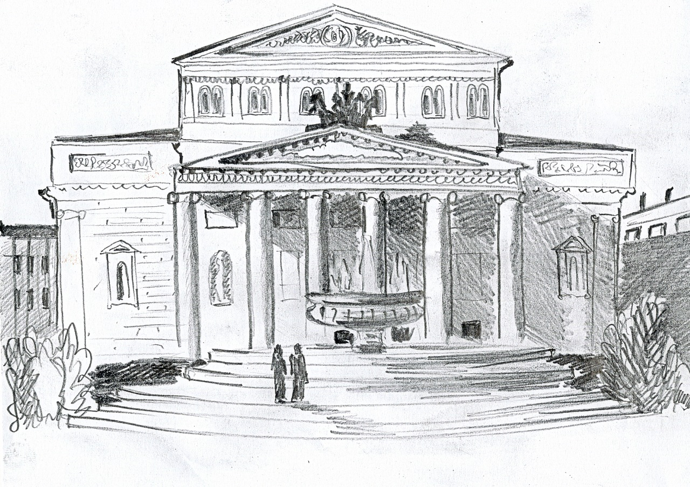

# Project InfoPack

Youth Exchange Project “Theatre of Europe” funded by

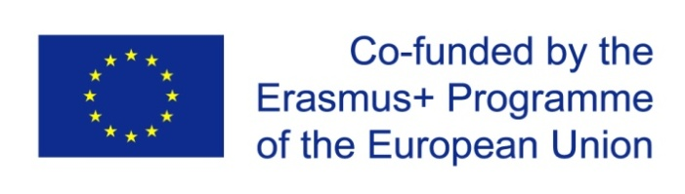ERASMUS + program

**Youth exchange is organized by Society** **“Daugavpils jauniešu savienība”**

and **4** **partner organizations:**

SYNCRO from Italy;

Dom Kultury "Zacisze"fromPoland;

Centrum voľného času from Slovakia and

A.C.T.O.R. from Romania

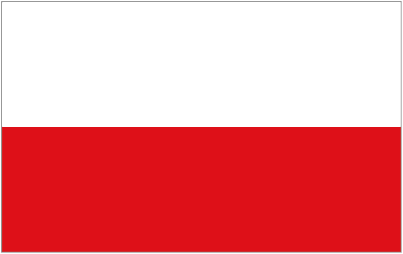

**ABOUT THE PROJECT**

The exchange project **“Theatre of Europe”** will run in Daugavpils for day 01.01.2016- 30.09.2016.

***Activities in Latvian city Daugavpils will run from 20.05.2015 to 29.05.2015.***

The topic of the project is theatre and creativeness, social inclusion.

***The aim of the project "Theatre of Europe" is to promote the personal effectiveness and tolerance of youth against different social realities through the theatre art.***

The project activities will run 10 days (20.05.-29.05). There will participate 30 young people from Latvia, Poland, Italy, Slovakia and Romania.

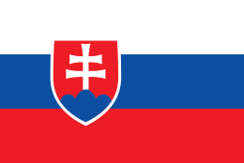***Within the project will be used the following methods: presentations, brainstorming, discussions, interviews, individual, group and team works, ice-breaking activities, team making activities, energizers, activities with the theatre techniques, creative tasks, theatrical performances.***

During the project the youth will be acquainted with the cultures of European countries. They will acquire the skills to understand the representatives of the present cultures in the context of theatre art, will acquire methods of verbal and nonverbal communication and use them in practice, as well as will discover their creative potential participating in different theatrical performances. The young people will have the possibility to show all their skills, abilities and talents in the field of theatre to the society of Daugavpils city by making a performance in Daugavpils.



**Daugavpils** is a city in southeastern Latvia located on the banks of Daugava River, from which the city gets its name. Daugavpils literally means “Daugava Castle”. Daugavpils has a favorable geographical position as it borders [Belarus](http://en.wikipedia.org/wiki/Belarus) and [Lithuania](http://en.wikipedia.org/wiki/Lithuania) (distances of 33 and 25 km respectively). It is located some 120 km from the Latvian border with [Russia](http://en.wikipedia.org/wiki/Russia). Daugavpils is a major [railway junction](http://en.wikipedia.org/wiki/Junction_%28rail%29) and industrial centre. The city is surrounded by many lakes and nature parks.

The town's history began in 1275 when the [Livonian Order](http://en.wikipedia.org/wiki/Livonian_Order) built [Dünaburg castle](http://en.wikipedia.org/wiki/Dinaburga_Castle) 20 km up the Daugava river from where Daugavpils is now situated. In 1561 it became part of the Polish Lithuanian Common Wealth and in 1566 became capital of the Inflanty Voivodeship, which existed until the [First Partition of Poland](http://en.wikipedia.org/wiki/First_Partition_of_Poland) (1772). In 1577 the Russian tsar [Ivan the Terrible](http://en.wikipedia.org/wiki/Ivan_IV_of_Russia) captured and destroyed Dünaburg castle. That same year, a new castle was built 20 km downriver. In 1582 Daugavpils was granted [Magdeburg town rights](http://en.wikipedia.org/wiki/Magdeburg_rights). In the 17th century, during the [Russo–Swedish War](http://en.wikipedia.org/wiki/Russo-Swedish_War_%281656%E2%80%931658%29) initiated by Tsar [Alexis of Russia](http://en.wikipedia.org/wiki/Alexis_of_Russia), the Russians [captured](http://en.wikipedia.org/wiki/Siege_of_Dyneburg) Daugavpils, renamed the town *Borisoglebsk* and controlled the region for 11 years, between 1656 and 1667. Russia returned the area to Poland following the [Treaty of Andrusovo](http://en.wikipedia.org/wiki/Treaty_of_Andrusovo) (1667). Nowadays, in terms of population, Daugavpils is the second-largest town after Riga which makes it an important economic, cultural and tourism centre and a home for one of the biggest regional universities- ***Daugavpils Pedagogical University*** (now Daugavpils University). In the city are also located 22 primary and secondary schools, four vocational schools, the ***Saules College of Art*** and the local branch of ***Riga Technical University*.** A couple of years ago was restored the city theatre. There is also one cinema as well as other cultural institutions. The city exhibition center offers many cultural activities.

**PLACE AND AROUND**

The symbols of the city are the 19th century fortress and the Church Hill that has gathered the churches of four different confessions. The most attractive place in the city is historical centre of Daugavpils which is also an architectural heritage of national importance (the construction work was carried out in the 19th century according to the project endorsed in St Petersburg in 1826). The construction makes Daugavpils one of the few cities which can pride itself on a unified ensemble of both classic and eclectic styles. The cultural and historical heritage, including town planning, architectural, artistic, industrial and historical monuments, together with the picturesque surrounding landscapes shapes the image of Daugavpils and adds special charm to the city.

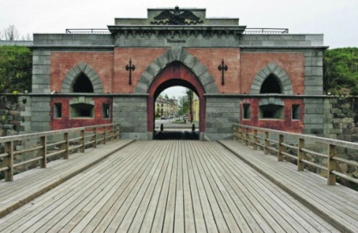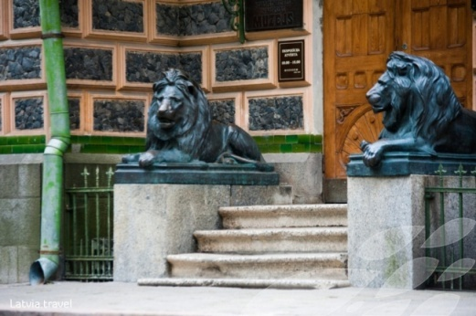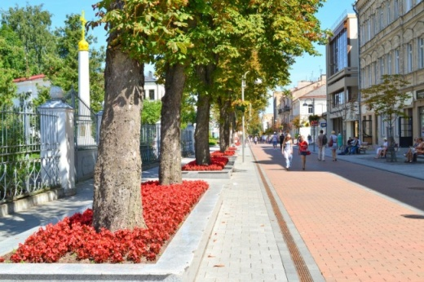

**PROGRAM and WORKING METHODS**

**There will be organized the following activities:**

* discussion and brainstorming about the theatre and its role in our life;
* excursion to Daugavpils theatre;
* meetings with local actors;
* vocal exercise, during which participants will be shown a variety of methods how to train their voice and to improve vocal;
* activities, based on theatre methods, such as dumb show, theatrical competitions etc.;
* youth acquaintance with the EU main values: democracy, tolerance and respect, freedom, human rights;
* presentations about Italian, Romanian Slovak, Polish and Latvian theatrical art, prepared by participants;
* culture evenings;
* daily reflection;
* final event of this project will be participants performance on the following topics: democracy, equality, respect, observation of human rights or/and European youth values;

As a result of planned activities the youth will be acquainted with the cultures of European countries. They will acquire the skills to understand the representatives of the present cultures in the context of theatre art, will acquire methods of verbal and nonverbal communication and use them in practice, as well as will discover their creative potential participating in different theatrical performances.

**PARTICIPANTS**

**Due to the plan, the young people at the age of 16 to 30 (1 leader + 5 youths) will take part in the project together with young people from Latvia, Italy, Poland, Romania and Slovakia. All the project participants will live in the hotel “ERFOLG” which is situated in Daugavpils where the main activities will take place.**

**NOW EACH PARTNER (GROUP LEADERS) SHOULD COMPLETE THEIR PARTICIPANTS AS SOON AS POSSIBLE WHICH IS THE FIRST STEP FOR PREPARATION, BECAUSE GROUPS SHOULD START TO BUY THEIR TICKETS.**



**TRAVEL COSTS AND TRAVEL DAYS**

Travel costs will be covered according to distance calculator according to distance between place where participants live to venue of the project. <http://ec.europa.eu/programmes/erasmus-plus/tools/distance_en.htm>

|  |  |
| --- | --- |
| KM | EUR |
| 0 - 99 | 0 |
| 10 - 99 | 20 |
| 100 - 499 | 80 |
| 500 - 1999 | 170 |
| 2000 - 2999 | 270 |
| 3000 - 3999 | 400 |
| 4000 - 7999 | 620 |
| 8000 - 19 999 | 830 |

*The groups will buy their tickets and maximum 2 weeks after the project when everybody sent their boarding passes and leaders will fill in mobility tools, the reimbursement for travel cost will be made by bank transfer.*

FIRST ACTIVITY DAY OF PROJECT IS 20TH OF MAY SO MAKE SURE THAT YOU ARRIVE TO DAUGAVPILS ON THE 20TH OF MAY BEFORE 19.00. AND YOU WILL LEAVE DAUGAVPILS ON THE 29TH OF MAY. When you will arive to Riga we recomend you to use train or bus services to get into Daugavpils (Riga –Daugavpils):

|  |  |  |  |  |  |  |  |
| --- | --- | --- | --- | --- | --- | --- | --- |
| **Train** | | | | **Bus** | | | |
| Rīga | Daugavpils | In the way | Price of the ticket | Rīga | Daugavpils | In the way | Price of the ticket |
| 07:40 | 11:30 | 03:50 | **7.05 Eur** | 04.00 | 07.40 | 03.40 | **8.90 Eur** |
| 15:45 | 19:10 | 03:23 | 07.30 | 11.10 | 03.40 |
| 16:46 | 21:07 | 04:21 | 08.40 | 12.30 | 03.50 |
| ***You can find the transport list of the trains and buses here:***  *http://www.1188.lv/transport* | | | | 10.00 | 13.40 | 03.40 |
| 11.50 | 16.05 | 04.15 |
| 13.35 | 17.35 | 04.00 |
| 14.30 | 18.10 | 03.40 |
| 15.30 | 19.10 | 03.40 |
| 18.05 | 21.50 | 03.45 |
| 19.20 | 23.00 | 03.40 |
| 20.20 | 23.59 | 03.39 |

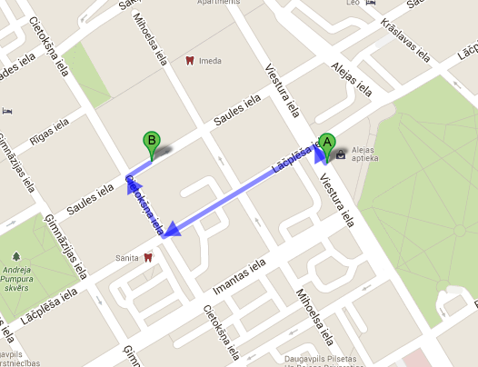

*If you will drive by bus then on the map bellow you can see how to get to our Society „ERFOLG” office.*

Where:

**A:** Bus station

**B:** Society Erfolg office

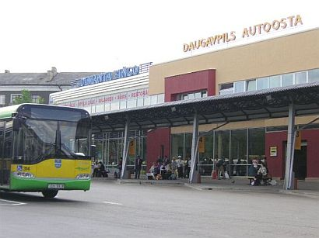

*If you are driving by train then on the map bellow you can see how to get to our Society „ERFOLG” office.*

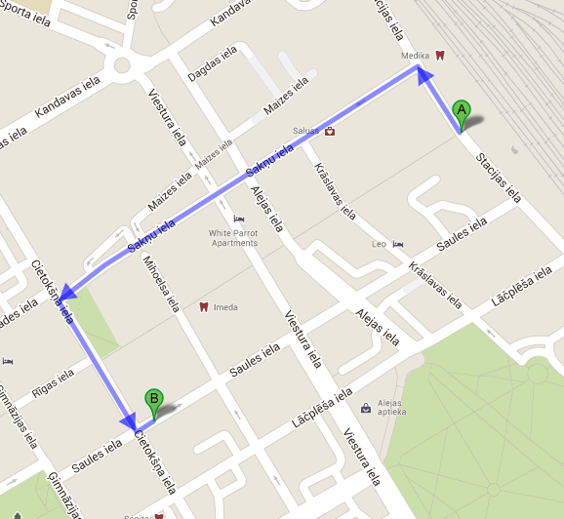

Where:

**A:** Railway station

**B:** Society Erfolg office

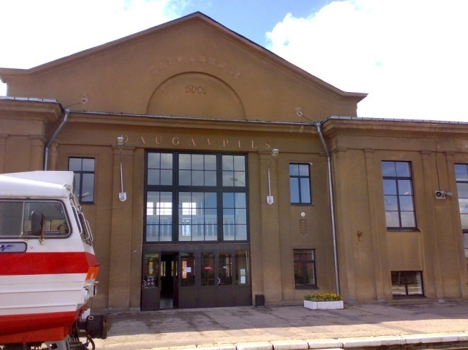



Anyway our volunteers will meet you on the railway or bus station! ☺

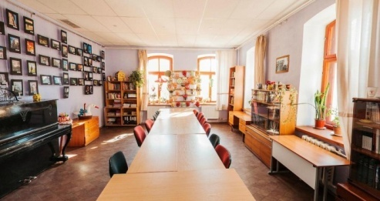

**Meeting place: Society „ERFOLG”**

T:(+**371) 20371892, (+371) 65420019**  
E-mail : [**society_erfolg@outlook.com**](mailto:society_erfolg@outlook.com)

Address: Cietokšņa Street 44, Daugavpils

**Some useful phrases in Latvian:**

|  |  |
| --- | --- |
| **Latvian –** English | |
| **Jā** – yes  **Nē** - no  **Lūdzu**  - please  **Paldies**  - thanks  **Liels paldies** - thank you very much  **Labrīt**  - good morning  **Labdien**  -good afternoon  **Labvakar** - good evening | **Atā** - bye  **Uz redzēšanos** - goodbye  **Ar labunakti** - goodnight  **Ieeja** - entrance  **Izeja** - exit  **Grūst** –push  **Vilkt**  - pull  **Avārijas izeja** - emergency exit |

**Basic information about the Daugavpils city you can find here:**

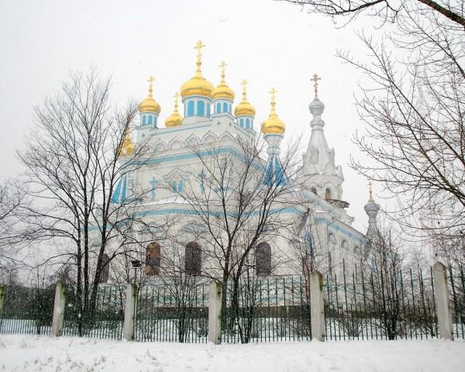

<http://en.wikipedia.org/wiki/Latvia>

<http://www.lonelyplanet.com/latvia>

<http://www.latvia.travel/en/tourist-information-centres>

<http://www.visitdaugavpils.lv/>

**Currency:**  **EURO**

**Project language:** **ENGLISH**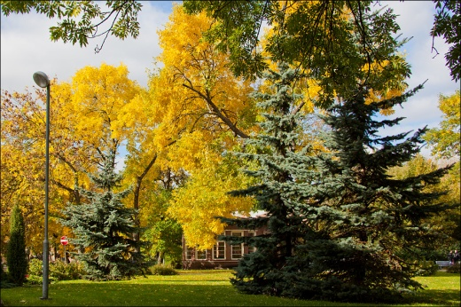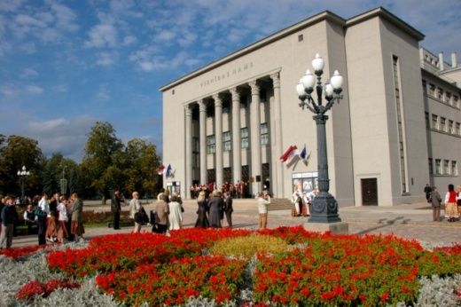

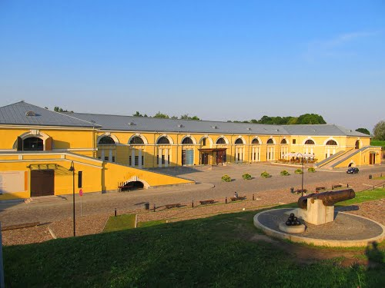

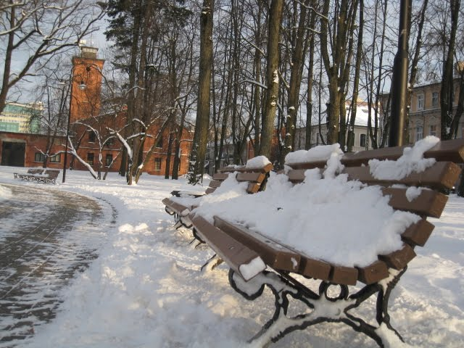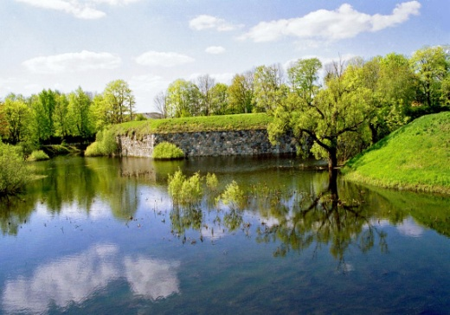

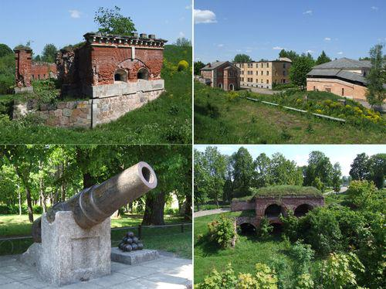

**ACCOMODATION**

**Hotel „ERFOLG” T: (+371) 25912250,**

**T: (+371) 65420019**

**Address: Nometnu Street 25a, Daugavpils, LV-5400, Latvia.**

**E-mail :** [hotelerfolg@inbox.lv](mailto:hotelerfolg@inbox.lv)

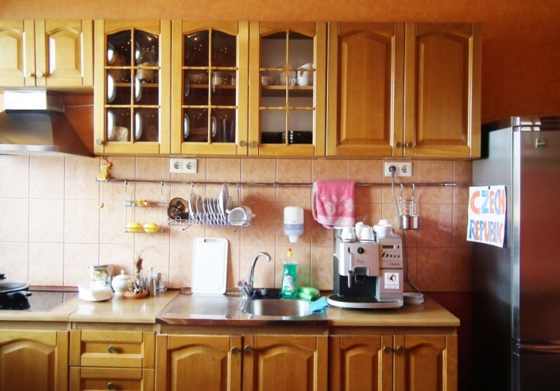**NOTE: be ready to walk ±1km each day in order to get from accommodation place to the place of activities ☺**

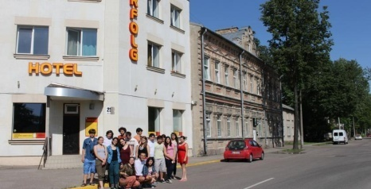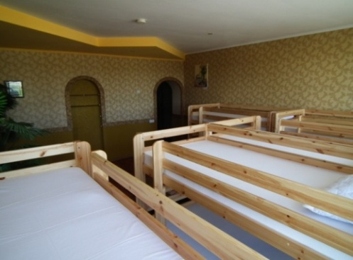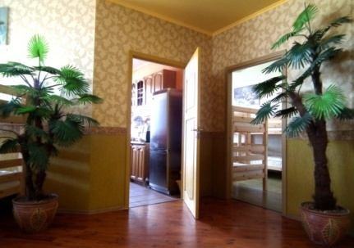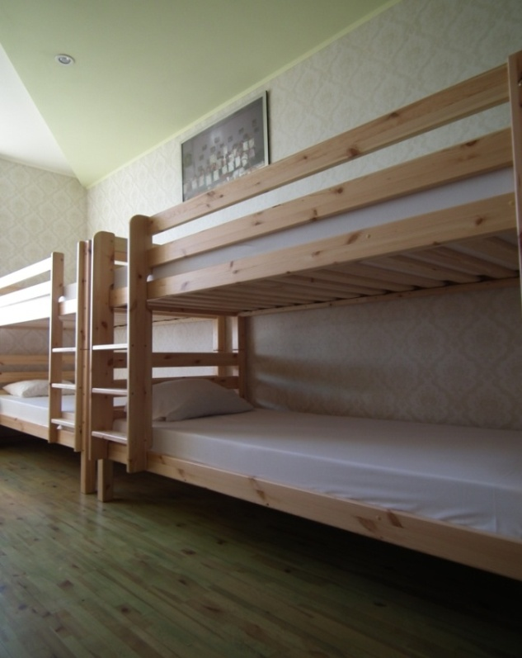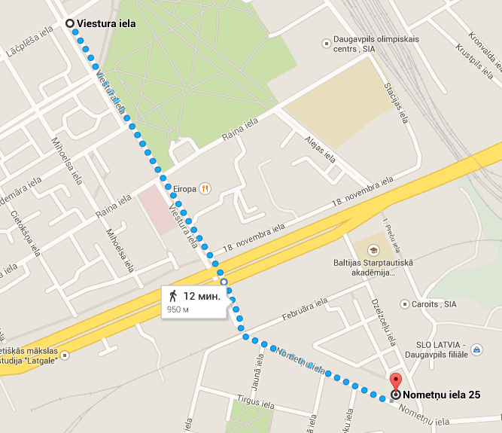

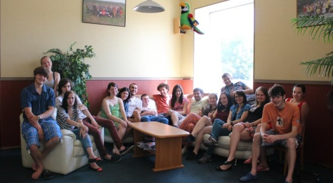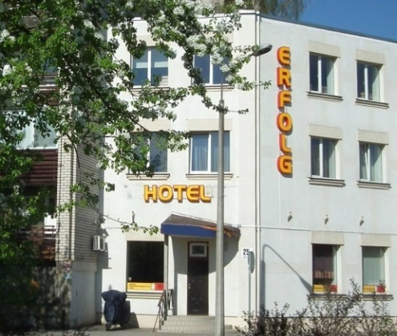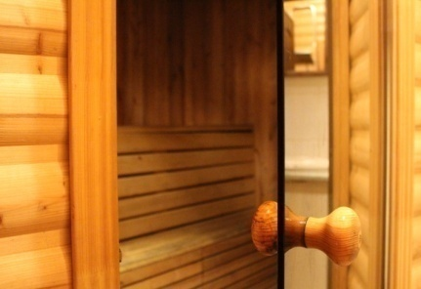



**HOMEWORK**

1. **Prepare presentation or report about theatrical art of your country and 5-10 min long theatrical scene which can be based of any storyline: drama, poetry, story or life situation etc., depending on your choice;**
2. **Presentation about organization you represent;**
3. **Prepare programme for your national evening;**
4. **Find and try out some creative energizers and teambuilding activities.**

**PREPARATION AND CHECK LIST**

* *Collectalltheparticipants and maketheteam;
* *Buy the tickets and contact us, send us a copy of your ticket and your travel information;
* *Get the energy to travel and have great 10 days in Latvia;
* *Do not forget to take along slippers, comfortable shoes and clothes, umbrellas;
* *Prepare group home works;
* *Each national group need to take a small flag of native country;
* *Do not forget to join our facebook group

**https://www.facebook.com/groups/1575456029412453/**

For more information and questions you can contact us by e-mail address [society_erfolg@outlook.com](mailto:society_erfolg@outlook.com) or phone number (+**371) 20371892, (+371) 65420019,**

## SEE YOU IN THIS EXCITED INTERNATIONAL ADVENTURE!

Society „ Daugavpils jauniešu savienība”